Is Solo Email Marketing Still Worth It in 2025?
“Solo email marketing can still drive traffic and leads in 2025. See what’s working now and how to get the most out of your campaigns this year!”
You’ve probably tried just about everything to drive traffic and generate leads—Google ads, social media, maybe even content marketing. Yet, somehow, the results just don’t add up the way you’d hoped.
If you’re fed up with spending money on ads that barely convert or wasting time building an email list that grows at a snail’s pace, I’ve been there, too.
“Solo email marketing is a quick and easy way to get traffic!” That’s what you hear everywhere.
But there’s more to the story—it’s not always that simple.
About nine years ago, when I first tried solo email marketing, I thought it would be the fastest way to drive leads and traffic. I mean, why wouldn’t it be?
Pay someone with a big email list to promote your offer, sit back, and your offer will instantly reach thousands of people. It sounded foolproof.
Well, not exactly.
My first attempts didn’t go as planned. I lost money and wasted time, mostly because I didn’t fully understand how it worked, and I didn’t start getting results until when I changed my approach.
But here’s the truth—solo email marketing can work, even in 2024—if you know how to do it right.
In this guide, I’ll share what I’ve learned to help you avoid the mistakes I made and get better results from the start.
Here’s what I’ll cover:
- What solo email marketing is and how it works.
- How to find the right solo ad provider (so you don’t waste your budget like I did).
- How to avoid the common mistakes I made early on.
Sound good? Let’s get started.

What is Solo Email Marketing?
Solo email marketing is a way to promote your business by paying someone else to send your email to their list of contacts.
Let’s say you’ve developed an amazing new product, but your email list is still small. Instead of waiting to grow it on your own, you can partner with someone who has a large and engaged audience.
This person will send your promotional email to their subscribers, putting your offer in front of people who are really interested in what you’re selling.
This method is fantastic for anyone looking to quickly drive traffic or test new offers without spending so much time building their own email list. For example:
- If you’re launching a new course, you can find a solo ad provider who specializes in your field.
- They’ll help you reach people who are likely to sign up, saving you time and effort.
It’s important to choose the right solo ad provider to get the best results. Look for vendors who have a proven history of success. This ensures that your investment has a better chance of paying off.
Here’s why it’s worth considering:
- Speed: You can reach potential customers fast.
- Targeting: You connect with people who are already interested in what you offer.
If you approach it the right way, solo email marketing can significantly improve your overall email marketing strategy, and it could be just what you need for your business in 2024!

How Do Solo Ads Work?
Solo ads work by allowing you to promote your product or service through someone else's email list.
Here’s a simple breakdown of how it all happens:
- Find a Vendor: First, you need to find a solo ads vendor. This is someone who has a large email list of people who are interested in topics related to your business.
- Purchase a Solo Ad: Once you find a vendor, you buy a solo ad from them. This means you're paying them to send an email about your product to their list.
- Create Your Email: Next, you write an email that highlights your offer. Make it catchy and engaging so the readers will want to check it out.
- Vendor Sends Your Email: The vendor sends your email to their subscribers. This gives you access to a whole new group of potential customers who may not have heard of you before.
- Track the Results: After the email is sent, you monitor the results. You look at metrics like how many people opened the email, clicked on your links, or made a purchase. This helps you see how effective your ad was.
Let’s take a quick look at an example of a solo ad:
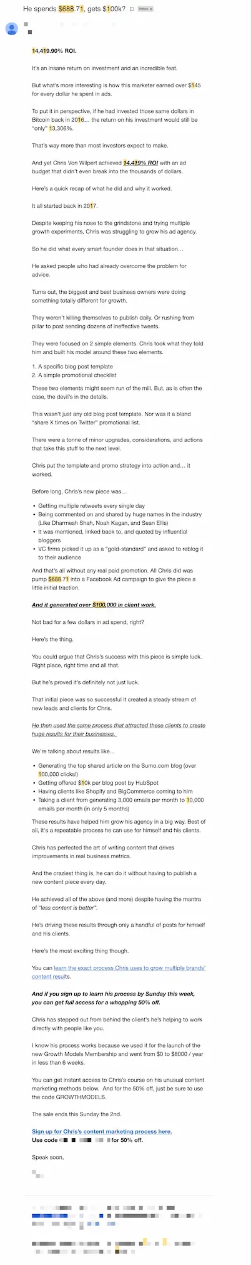
Notice how this email focuses on just one offer. This clear approach makes it easy for readers to understand what you are selling and encourages them to take action.
Solo ads are different from sponsored newsletters. Sponsored newsletters usually cover several topics, and the sender sets aside parts of the newsletter to highlight different sponsors.
For example, here’s a newsletter that includes an ad promoting Trends:
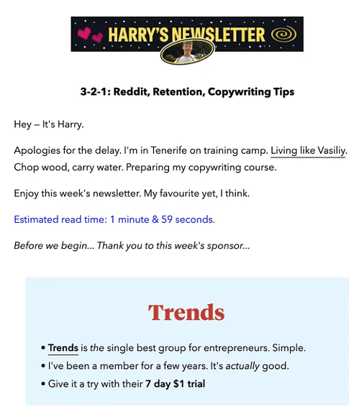
When you create your solo ad, focus on a few important parts:
- Subject Line: This is your first chance to catch attention. A good subject line like "Learn to Take Great Photos!" can make people want to open your email.

- Ad Copy: This is where you explain what you’re offering. Make sure to clearly explain what you're offering and why it’s valuable. Use engaging language and keep it simple. You could say something like, "Join my course and learn how to take stunning photos in just 30 days!"This shows readers what they can gain.
- Call to Action: Be clear about what you want the reader to do next. Whether it’s signing up for your course or downloading a free guide, make your call to action strong and straightforward. Phrases like "Sign up now for a free trial!" can prompt immediate action.
Solo ads give you a great way to reach a specific audience quickly.
With the right solo ad provider and a well-written email, you can connect with potential customers and drive traffic to your business. This method can help you achieve results faster and more easily!

Are Solo Ads Worth It?
Solo ads can be a great option for getting your business out there. They can work really well if you choose the right solo ad provider and know your audience.
For example, if you have a new cooking course, you want to partner with a solo ad provider whose audience is interested in cooking and recipes. This way, your email goes straight to people who might want to join your course.
Here are a few things that make solo ads worth it:
- Targeted Traffic: Solo ads work best when the audience matches what you're offering. If people are interested in what you sell, they're more likely to click and engage.
- Quick Results: With solo ad campaigns, you can get your message out quickly. This is especially useful when you launch a new product or service. You don’t have to wait for weeks to build your own email list.
But be careful! Not every solo ad vendor is trustworthy.
Some may not deliver quality traffic. Always check reviews and ask for examples of their previous campaigns. You don’t want to waste your money on ads that don’t bring in results.
Here are some testimonials from Udimi's solo ads marketplace, where buyers have reported making sales from a solo ad vendor. These reviews show how solo ads can help attract more visitors and gain new customers for different products and services.
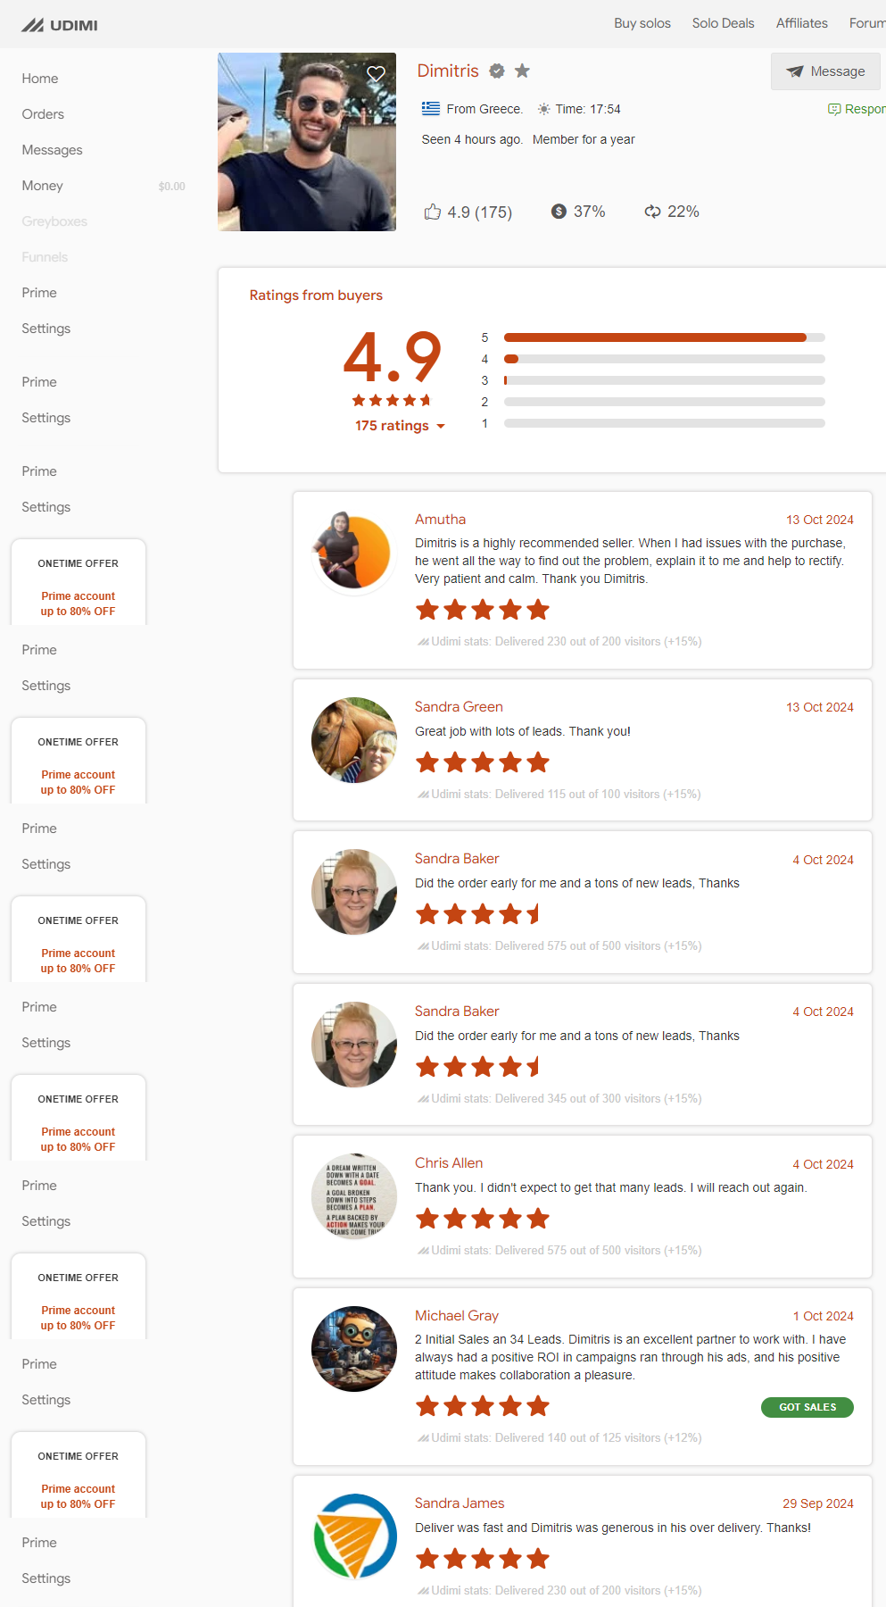
Feel free to check out Udimi for more success stories and helpful insights!
In short, solo ads can be worth it if you do your homework. Pick a reputable solo ads provider, and make sure their audience fits your product.
With the right approach, solo ads can be a useful part of your email marketing plan!

How to Pick the Right Solo Ad Provider
Finding the right solo ad provider can be a big step toward growing your business. With so many options out there, it’s easy to feel a bit lost.
But don’t worry! Here’s how to find a good one.

a). Do Your Research on Solo Ad Sellers
There are plenty of solo ad sellers available, and many of them make money by using the email lists they have built.
Most solo ad sellers are small business owners or solopreneurs looking to earn some extra cash. It’s important to know who the solo ad seller you’re working with is to ensure you get good results.
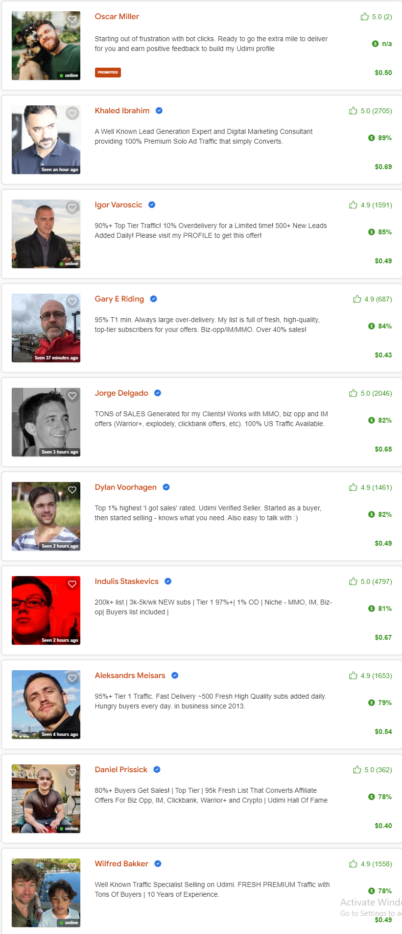

b). Check Reviews and Testimonials
Look at what other buyers say about the vendor.
If you see lots of happy customers saying things like, “I got tons of leads from this solo ad!” that’s a good sign. Positive feedback means they know what they’re doing.

c). Look at Their Track Record
A reputable solo ad provider should show proof of successful past solo ad campaigns. Ask for results from their previous ads. If they can show you how many clicks and sign-ups they’ve had, you’re in good hands.

d). Where to Find Them
You can find great solo ad vendors on various solo ad marketplaces. For example, Udimi is a popular platform where you can order solo ads.
Here, you can filter sellers by niche, check their ratings, and view their past performance, including sales generated and repeat orders.
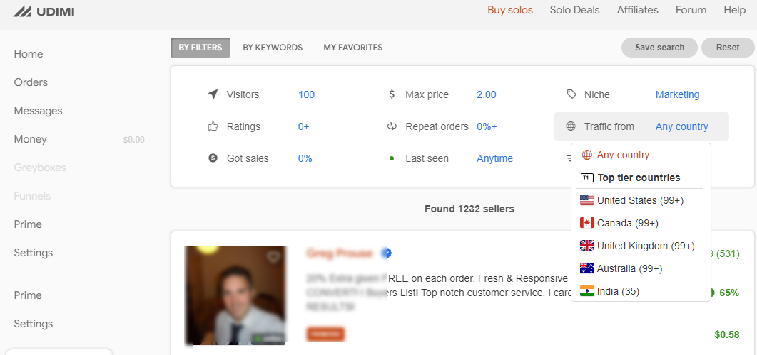
- Udimi: A well-known site for buying and selling solo ads, with ratings for each vendor.
- TrafficForMe: This platform focuses on getting good traffic from interested people.
- Warrior Forum: A popular online community where marketers share their experiences and tips for solo ad providers.
- Facebook Groups: Many marketers talk about solo ads and share their experiences in different groups.
- SoloAdDirectory: This site lists different solo ad providers and what they offer.

e). What to Avoid
If a vendor has many complaints or doesn’t show clear stats, stay away. You want to avoid losing money on low-quality traffic that won’t help you.
To sum it up, take your time to do some research. Choosing the right solo ad vendor can significantly improve your results.
With the right choice, you can connect with the right audience and drive traffic to your business through solo ads!

How Much Do Solo Ads Cost?
When it comes to solo email marketing, knowing the cost of solo ads is important for your budgeting. The prices for solo ads can vary quite a bit, so it’s good to have an idea of what to expect.
Generally, you can pay anywhere from $0.30 to $1.00 per click. The exact solo ad cost depends on several factors, including:
- Niche: Some topics are more competitive than others. For example, if you're promoting a popular weight loss program, the cost might be on the higher end. In contrast, a niche hobby might be cheaper.
- Quality of Traffic: If you choose a solo ad provider known for delivering high-quality traffic, you may pay a little more. However, this often means you’ll see better results in terms of clicks and sign-ups.
- Size of the List: A provider with a big email list might charge more, but they can bring in more clicks, which is worth considering.
If you're worried about the costs, here are some tips:
- Start Small: It's a good idea to start with a smaller budget to see how things go. This lets you see how well the ads perform without spending too much upfront.
- Don’t Assume High Prices Equal Quality: Just because an ad costs more doesn’t mean it will deliver better results. Look for solo ad vendors with positive reviews and solid proof of past success.
So, is solo email marketing too expensive for small businesses? Not necessarily.
It can be affordable if you choose the right solo ad provider and manage your budget well. With the right approach, solo ads can provide a great return on investment!

How to Make Solo Ads That Actually Work
I’ve seen this happen several times: you send out a solo ad, hoping for tons of clicks, but the results just don’t match your expectations.
You want to get your ad noticed, clicked, and acted upon. So, what’s the key to making it work?
The trick is to get people interested, keep them engaged, and lead them to take action—all in a few short lines.
Sounds like a lot, but when you focus on three key things—your subject line, ad copy, and call to action—it becomes much easier.
Let’s break it down step by step.

a). Start with a Strong Subject Line
Your subject line is the first thing people see, so it needs to grab their attention fast.
Think of it as the door to your ad—if it’s not inviting or relevant, no one’s going to open it. A good subject line gets straight to the point but also sparks curiosity.
- Example of a weak subject line: "Our New Product is Here!"
This is boring and doesn’t tell the reader why they should care. It’s too focused on you.

- Example of a strong subject line: "Want to Solve [Problem]? Here’s Your Quick Fix."
This one is much better because it taps into what the reader cares about—solving a specific problem.
Tip: Keep it short and catchy, around 5-7 words. Readers are busy, so make it quick but relevant. Instead of just saying, "Special Offer Inside," say something like, "Get 20% Off Your Next Order Today!"—make them feel like they can’t miss out.

b). Write Clear-Ad Copy That Speaks to the Reader
Once they open your email, you need to keep their attention.
Your ad copy should be clear and simple, focusing on how you can help them, not just what your product is. People don’t care about features as much as they care about benefits.
- A good ad copy is written as if you’re talking directly to the reader’s needs.
- Bad ad copy talks too much about features and technical details.
Example of bad ad copy:
"Our software includes 10 features that improve website speed and has advanced SEO tools."
Example of good ad copy:
"Struggling with a slow website? Our tool helps you speed things up, so your visitors stick around longer and you rank higher on Google. Click below to see how you can get more traffic today."
Notice how the good copy focuses on what the reader cares about—getting results? This makes it much more relatable and persuasive.
Here are a few pointers for writing good ad copy:
- Keep it simple: Write in everyday language, like you’re having a conversation with a friend. Avoid jargon or complicated terms.
- Focus on benefits: Ask yourself, “What’s in it for them?” and build your copy around that.
- Make it personal: Speak directly to the reader—use “you” and “your” so it feels like you’re talking to them, not at them.

3). End with a Strong Call to Action
Now that you’ve got their attention, you need to tell them exactly what to do next. A good call to action (CTA) is clear, direct, and easy to follow.
You want them to take action—whether that’s signing up, buying, or downloading something.
- Example of a weak CTA:
"Learn more about our services."

- Example of a strong CTA:
"Call us today to book your free consultation, and we’ll help you plan your perfect garden makeover!"
The key is to make it as specific and direct as possible. Don’t leave them guessing what to do next.
Be clear: do you want them to buy something, sign up, or click a link? Tell them exactly what step to take.
Some tips for a strong CTA:
- Be clear and direct: Don’t just say, "Click here." Tell them why they should click and what they’ll get from it.
- Use action words: Words like “Get,” “Start,” “Download,” “Join,” "Book," or "Claim" make it clear what action you want them to take.
- Create urgency: If there’s a time-sensitive offer, include that in your CTA. For example, “Sign up now—offer ends tonight!”

Good vs. Bad Ad Copy Example
Let’s look at two quick examples to really make this clear:
Bad ad copy:
"We’ve launched a new product that helps with email marketing. It has lots of great features. Check it out!"
Good ad copy:
"Tired of low open rates on your emails? Our new tool boosts engagement by up to 50% in just a few clicks. Click here to see how you can improve your email marketing today."
In the good example, it’s clear how the product will help solve the reader’s problem. It’s all about showing the benefits, not just listing features.
Here’s a tip: always test different versions of your ad. See which subject lines or calls to action get the most clicks. By tweaking your ad based on what works, you can create solo ads that truly connect with your audience.
So, when you’re putting together your solo ads, keep these things in mind:
- Catch their attention with a strong subject line.
- Keep it simple and focused on benefits in your ad copy.
- Tell them exactly what to do next with a clear call to action.
When you talk directly to your audience like this, you’re not just sending another email—you’re connecting with people who need what you have to offer.
And that’s how you make solo ads that actually work.

Building a Landing Page That Converts
After someone clicks on your solo ad, the next stop is your landing page. This is where you can really make an impact and get them to take action.
To ensure they don’t leave without doing something, your landing page must be designed well and match the promise of your ad.
Here’s how to create a landing page that converts:

a). Match Your Ad
Your landing page should continue the conversation started in your solo ad.
For example, if your ad offered a free meal plan for healthy eating, your landing page should immediately present that meal plan and explain its benefits. This keeps everything clear and relevant for the visitor.

b). Key Elements:
- Simple Design: Keep the layout clean and easy to read. Use plenty of white space to help guide the reader’s eye. If your landing page is about a meal plan, show appealing images of healthy meals to entice the visitor without overcrowding the page with too much text or too many images.

- One Clear Call to Action: Decide on one action you want the visitor to take, such as “Download Your Free Meal Plan” or “Get Started Today!” Make this call to action stand out by using bold colors or larger fonts. Place this button above the fold so it’s visible without scrolling. The goal is to make it obvious what the visitor should do next.

- No Distractions: Avoid links to other pages or extra information that could confuse visitors. Your focus should be on encouraging them to take the desired action. If your landing page offers too many options, visitors may feel overwhelmed and leave.

c). Testing Your Landing Page
Don’t be afraid to make changes based on how your page performs. Use A/B testing to try different headlines, call-to-action buttons, or images to see what gets the most clicks.
For example, switching the button color from blue to green could lead to more downloads. Small changes can lead to big improvements!

d). Use Engaging Content
Consider adding testimonials or success stories to your landing page. If people see that others have benefited from your offer, they’ll be more likely to trust you and take action.
When running a solo ad campaign, these tips can help you convert solo ad traffic into leads or sales. If you want to sell solo ads or are just starting with solo advertising, remember that a strong landing page is essential.
Focus on these things, and you can build a landing page that will convert visitors into customers and help your business grow!

How to Tell If Your Solo Ad Campaign is Working
Once your solo ad campaign is live, the big question is, "Is it working?"
There are a few key metrics you can look at to understand how well your campaign is performing and whether your investment in solo ads marketers is paying off.
Key Metrics to Track

1). Click-Through Rate (CTR)
This shows how many people clicked on the link in your email compared to how many received it.
A higher CTR means your ad copy and subject line did their job of grabbing attention. If your CTR is low, you might need to improve these elements.

2). Conversion Rate
Getting clicks is great, but what really matters is how many of those clicks turned into actions, like signing up for a newsletter or buying a product.
The conversion rate tells you how many people followed through on your call to action. If you're seeing a high CTR but a low conversion rate, your landing page might need some work.

3). Leads or Sales Generated
The ultimate goal of any solo ad campaign is to generate leads or make sales. Keep an eye on how many new subscribers you gained or how many sales you made from the traffic the solo ad brought in.
To keep tabs on these numbers, use tools like Google Analytics or tracking features from your solo ad vendor. They make it easy to see how well you’re doing.

Improving Future Campaigns
Even if your current campaign did well, there’s always room for improvement. To increase future performance:
- Test Different Subject Lines: A small change in your subject line can dramatically improve your open rate.
- Tweak Ad Copy: Experiment with different messages to see what resonates with your audience.
- Change Your Solo Ad Provider: If you’re not getting the results you want, consider testing other solo ad vendors. They may have better-targeted audiences for your product.

Common Mistakes to Avoid with Solo Ads
When you’re starting with solo email marketing, it’s easy to some common mistakes.
I’ve made plenty of them myself, and believe me, you want to avoid these if you don’t want to lose money.
Here are some things to watch out for:

1). Not Tracking Results
One big mistake is not keeping track of how well your solo ad campaigns are doing. If you don’t measure the results, you won’t know if your money is well spent.
Use tools like Google Analytics to see how many people clicked on your ad and if they signed up or bought anything. This information helps you understand what works and what doesn’t.

2). Choosing the Wrong Audience
Another mistake is not checking if the audience matches your product. If you pick a solo ad provider whose list doesn’t fit your offer, your ad might not reach the right people.
For instance, if you’re selling pet products, make sure the audience includes pet owners. This will increase your chances of getting good results.

3). Overpaying for Bad Traffic
It's easy to assume that higher prices mean better quality, but that’s not always true. Some people end up paying a lot for solo ads but don’t get good results.
Start with a small budget to test different vendors before spending more money. This way, you can find out which ones work best for you.

4). Ignoring Vendor Reviews
I once made the mistake of not reading reviews about the solo ad provider I chose. I didn’t check what other customers said and ended up disappointed.
Always look for feedback from past buyers. If a solo ads vendor has many positive reviews, they’re more likely to provide good traffic.

5). Lack of a Clear Call to Action
Your solo ad needs to tell readers what to do next. If they don’t know whether to sign up for a newsletter or make a purchase, they might just leave. Make sure your ad clearly states the next step you want them to take.
Avoiding these mistakes will help you refine your solo ad campaigns and better connect with your target audience!
And with that, you’ll be on your way to seeing the results you hoped for from your solo ads.

Final Thoughts
So, is solo email marketing still worth it in 2024? Absolutely—if you use it the right way.
It’s great for lead generation and driving traffic fast, especially if you’re targeting a specific group. But just like with anything else, you need to be careful and think it through.
Start small and test your campaign to see what works. Don’t just throw money at it and cross your fingers.
Keep an eye on your results, make changes where needed, and your future campaigns will keep improving. In the end, solo ads can really pay off if you’re willing to learn as you go.
Give it a shot, but remember to track everything, learn from the results, and keep refining your approach.
Results will follow, and you’ll get better with each step!

Plagarism free: https://prnt.sc/prbHQc9YO_Ty

